**MDF Rose Engine Lathe 2.0**

**with Stepper Motor Drive**

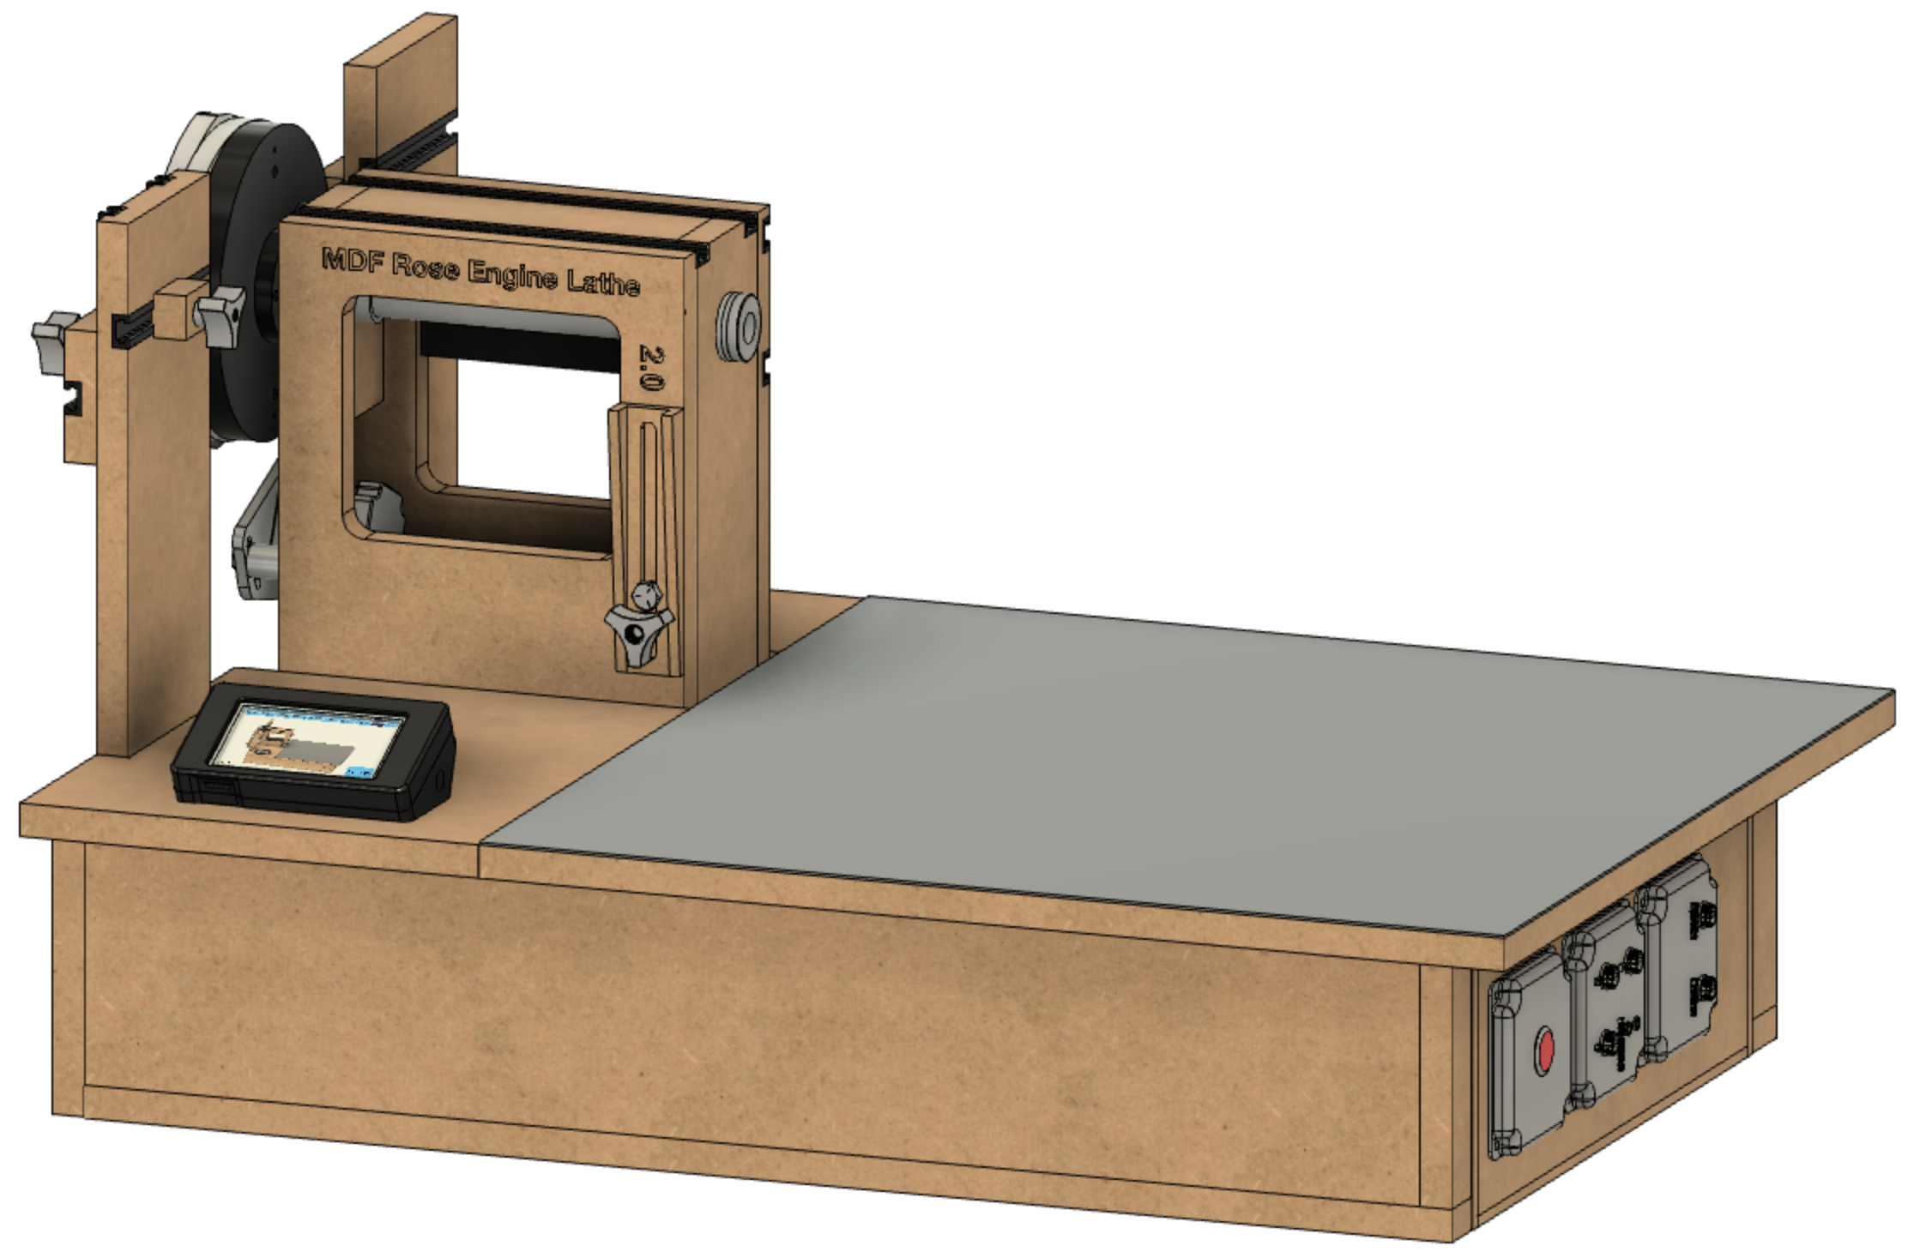

**User Manual**

**Version 1.1**

**30 December 2021**

This document is intended to help one obtain the best output from their MDF rose engine lathe. It is a "back to the basics" document that is good to keep handy and review periodically. Doing so has helped me ensure I do not get into bad habits. Ornamental turning is not for the impatient, and these steps will help ensure that the result of a slow turning process will not be wasted.

Special thanks to the Nerds of Woodworking for their help in compiling these.

If you have any questions, please contact us at [ColvinTools@Gmail.com](mailto:ColvinTools@Gmail.com).

Good luck.

Rich Colvin & Jack Zimmel

Table of Contents

Nomenclature 4

Protect Your Health 5

Getting Started 6

Startup Checklist 7

Paper Chucks 14

Recommended Maintenance 15

Quarterly Maintenance 15

Annual Maintenance 15

Standards 16

Mechanical Standards 16

Electrical Standards 17

Design Goals 22

Frequently Asked Questions 23

What Changed with the MDF Rose Engine Lathe 2.0? 25

What Did Not Change with the MDF Rose Engine Lathe 2.0? 28

# Nomenclature

|  |  |  |  |  |  |  |  |  |
| --- | --- | --- | --- | --- | --- | --- | --- | --- |
|  | **Far Side** | | |  | |  |  | |
| **Outboard Side** |  | | | **Inboard Side** | |  |  | |
|  | **Near Side** | | |  | |  |  | |
|  |  | | |  | |  |  | |
| **Far Side** |  | **Near Side** |  | |  | | |
|  | |  |  | | --- | --- | | **Rear**  **Rubber**  **Support**  **Column** | **Front**  **Rubber**  **Support**  **Column** | |  |  | | **Lathe Axes** | | |

# Protect Your Health

Ornamental turning produces a lot of very fine dust, and this fine dust can be even more damaging than the sawdust you see. It is easy to inhale and can get deep into your lungs. Eric Meier noted on *“The Wood Database”*,

Forget about the large chips and visible sawdust: perhaps the most damaging element is the invisible fine dust (sometimes called "coarse inhalable particles" ranging from 2-10 microns). Basically, these tiny bits of sawdust float around the air and linger even after the tools have stopped running.

These invisible particles get inhaled and cause tiny wounds and scarring to our lungs: each time this happens, it causes a very small amount of irreversible damage. The immediate effect is unnoticeable, but over long periods of time, this can result in significantly decreased lung capacity, and a number of other health issues.

This is such a big enough issue that the United States Department of Labor's Occupational Safety and Health Administration (OSHA) has issued guidance and standards about it. They also noted,

Wood dust becomes a potential health problem when wood particles from processes such as sanding and cutting become airborne. Breathing these particles may cause allergic respiratory symptoms, mucosal and non-allergic respiratory symptoms, and cancer.

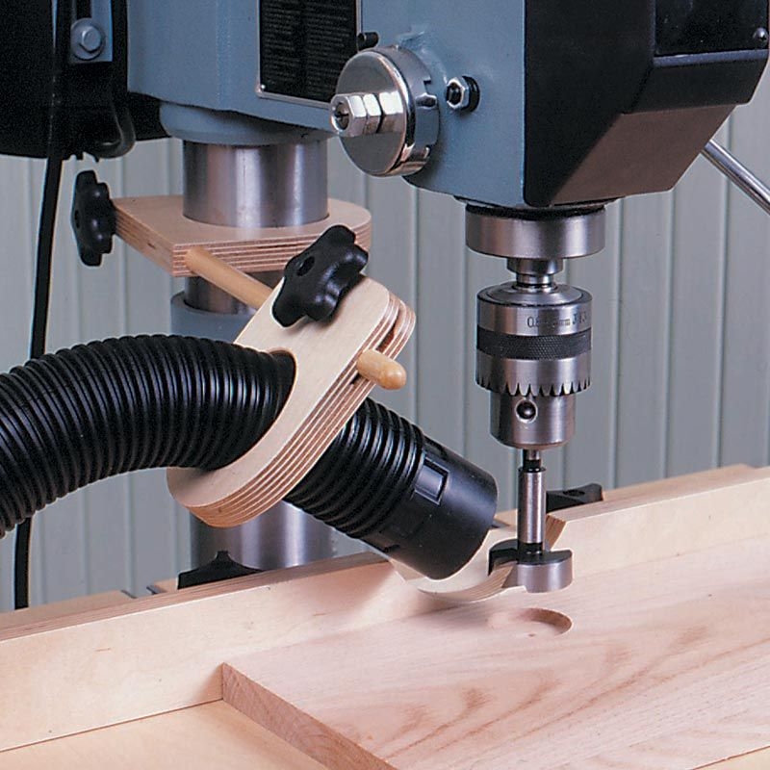Additionally, ornamental turning is usually done using wood which has a high probability of causing allergies and may even have some toxicity. Eric Meier has done a great job outlining this issue on his web site, “*The Wood Database”*. The list he has compiled contains quite a few woods commonly used.

I strongly recommend that you use a vacuum system with the intake as close to the cutting action as possible. The picture to the right shows dust collection on a drill press, but the same approach can be done on the rose engine lathe. Mine is held in a Noga arm which I move around to where it is most effective (but not intrusive).

An overhead air filtration is also recommended; something like the PowerMatic PM1200. There are other good ones, and I recommend you get such a machine when you can.

Figure - Drill Press Sawdust Collection

# Getting Started

When you are getting ready to start up a system using the Control System for Multiple Stepper Motors, ensure a microSD card is in the Teensy’s slot (or the extension). This will do two things:

1. Make for a faster startup as the Teensy will continue looking for such a card for a while if one is not seen, and
2. The list of files on the microSD card is only compiled at the system’s start. Inserting a card with files on it later will get ignored.

Once powered on, give it a few minutes to complete the boot process. It is not as slow a boot process as Windows but is not instantaneous either. Take this time to complete the steps below in the Startup Checklist.

# Startup Checklist

These steps are good ones to follow at the start of an ornamental turning session. They are practices learned after years of having not done them and regretted it when the end was achieved.

If you have questions about some of the terms below, consult the Ornamental Turning Book of Knowledge (https://OTBoK.info) which has a Dictionary of Language and Terms.

### Step 1: Center the headstock

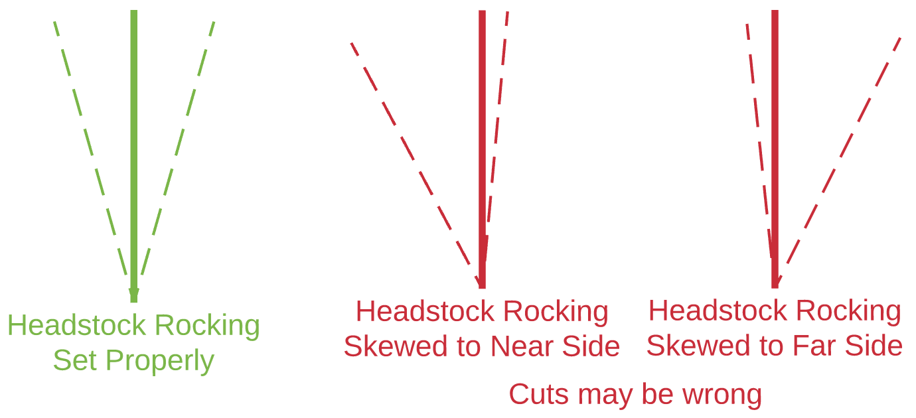**Note:** This step is only critical if you need to ensure the uniformity in a box's inside and outside surfaces. If you are not needing to do that, skip to the next step.

Figure - Headstock Swing

The steps outlined below ensure that the headstock rocks the same distance towards the far side as the near side. The diagrams shown on the below demonstrate the idea.

If the headstock rocks equally to both sides (as shown in the green above), then the planned rosette pattern will cut as expected. Conversely, if the headstock is set to rock unequally, (as shown in the red diagrams above), the pattern may be different than expected.

To center the headstock's movement (rocking) as shown in the green diagram, follow the steps below. There are other methods, but this is my favorite and the easiest.

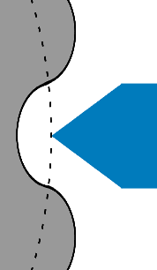Lock the headstock into a center position by dropping the centering block into the space between the headstock and the base, on the far side of the headstock. Then lightly hold the headstock against the block and drop the fading wedge down to hold the headstock in place.

Next, set the rubber in place. Rotate the spindle until the rubber can be set to be at the midpoint of the rosette's overall amplitude. Move the rubber forward to the halfway point and lock it down.

Figure - Setting the Rubber

Figure - Centering Block in Place

Unlock the headstock by raising the fading wedge and locking it into place, and then removing the centering block.

### 

### Step 2: Align the Object in the Chuck

After transferring an object from a "traditional" lathe to the rose engine lathe, there is a probability that it will not be radially or axially aligned (or both). Before making any cuts, ensure the alignment of the object whilst it turns slowly. A dial indicator is a great tool for this.

The bottom picture on the right is quite exaggerated but shows the idea of having the object misaligned.

Figure - Object is Aligned

If the rose engine's spindle has a Morse taper, and the chuck is held into place using a Morse taper adapter, then the object can be moved from one lathe to another and typically have very little misalignment. (This does assume you are not moving the object to a new chuck.) Another alternative is to use collet chucks.

Figure - Object is Misaligned

Frankly, I find this the most tedious task and when first starting I sometimes wondered about the value, but it is very important. If it is not done, then the cuts on one side of the object will be different than the other side. And it will get worse the further the cuts are made from the headstock.

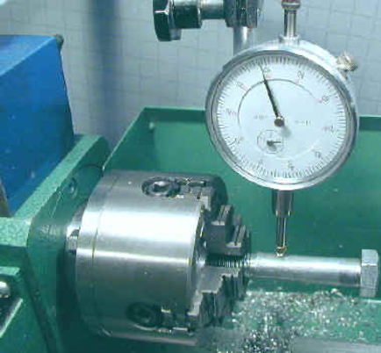When using the dial indicator (held in a Noga arm or similar device), I aim for a runout as small as possible, but oftentimes it is difficult to get under 0.010". This may seem quite big, but it is hard to achieve if you do not have a leveling chuck.

The picture to the left shows a dial indicator in use on a metal lathe. A similar approach would be used on the MDF rose engine lathe, though it is recommended that the measurements be made at the end furthest from the chuck / headstock.

Figure - Dial Indicator in Use

### Step 3: Choose the cutting frame or drill spindle to use

#### A picture containing icon Description automatically generatedCutting Frame

The cutter you use in a cutting frame drives what is achieved from the process.

The typical cutter is either a fly cutter cut to 60° or uses a carbide insert (also at 60°).

Other angles or shapes can be used, and the ones used for fly cutting are well documented in Holtzapffel's Turning and Mechanical Manipulation, vol. 5 - The Principles and Practice of Ornamental or Complex Turning. Some examples of these are shown to the right.

Figure - Traditional Fly Cutters

If you have multiple cutting frames, chose the one with the shortest reach that will do the job. There is no need to use one with 6" of reach when much less will get the job done. The shorter one has fewer opportunities for introducing vibrational errors.

#### Drill Spindle

Drill spindles offer a different set of options, and the shape of the drilling bit matters quite a bit. Shapes used typically follow the conventions established for milling bits.

The shape of the cutting edge is especially important when using an eccentric cutting frame. The typical fly cutter is ground with a 60° angle; however, jewelers have shown that the angle needs to be >90° for the cut so that the light is reflected back to the viewer. Otherwise, it simply looks like a set of thick dark lines. 120° is fairly common.

### Step 4: Align the Cutter

Figure - Cutter Alignment

The cutter needs to be aligned on the centerline of the spindle as shown in the picture to the right. This can be achieved by moving the cutting frame (or drill spindle) up or down in the quick-change tool post.

You can test the cutter's alignment on the end of a piece and see how it matches up with the images of cuts below.

|  |  |
| --- | --- |
|  |  |
| *Cutter Aligned too High* | |
|  |  |
| *Cutter Aligned too Low* | |
|  | |
| *Cutter Aligned Properly* | |

When the cutter is aligned too high in the quick-change tool post, it will create a pattern as shown in the first row of pictures to the left.

When the cutter is aligned too low in the quick-change tool post, it will create a pattern as shown in the second row of pictures.

When the cutter is aligned properly, it will create a pattern as shown in the third row.

This is where the indexing function in the Control System for Multiple Stepper Motors comes in quite handy. Indexing the cuts 90° after each cut makes the alignment verification easy.

One recommendation is to affix a scrap of wood to the end of the object and make cuts into that. (It can be held there using double-sided tape.)

**One note:** Sometimes you may want the cutter to be below or above the axis of the spindle to achieve your desired artistic effect. In that case, this step is even more important, though your target position will be different.

### Step 5: Align the Cross Slide to the Spindle

For most operations in ornamental turning, the path followed by the cross slide (the pink line) needs to be aligned on the centerline of the spindle (the red line) as shown in the picture to the right.

This allows it to work the same as the cross slide on a metal lathe (though on a metal lathe, the cross slide is attached to the lathe's bed ways).

The most accurate way to do this is with a dial indicator measuring against a straight rod affixed to the spindle (e.g., in the chuck).

Figure - Cross Slide Alignment

### Step 6: Ensure You are Cutting in the Correct Direction

|  |  |
| --- | --- |
|  |  |
| *Cutting to the Left* | *Cutting to the Right* |

**Note:** If you are not using a stepper motor to automate the movement of the cutter (e.g., on the Z, X, or B axis), then you can skip to the next step.

When cutting with a spinning cutter, just as on a router, it is important to always cut downhill. On a rose engine lathe, this invariably leaves the smoothest surface.

Based on the cutter's rotational direction (the blue arrow), the cutting frame's movement (the red arrow) should be set accordingly to accommodate down-hill cutting.

This is an advantage for using a fly cutter over carbide inserts, as a fly cutter's direction of rotation can be reversed. (For more information about fly cutters vs. carbide bits (see also Cutters on the Cutting Frames page at the *Ornamental Turning Book of Knowledge*.)

### Step 7: Set the Speed for the Cutting Tool

When I was getting started with ornamental turning, I asked how fast the cutter should be spun. The gentleman responded, "I run it as fast as I can without burning the wood."

It is common to use a variable speed motor like the midi lathe conversion kit from Penn State Industries for the overhead drive. To drive the belt, it is also common to use a multi-step pulley, with the pulley sizes at 4", 3", and 2" diameter. Based on that, the 4" pulley is used most often, and the 2" one almost never.

General ideas are:

* low density woods (like walnut) - run the cutter at maximum speed
* high density woods like ironwood - run the cutter at medium speed
* end grain on woods prone to burning (like maple) - run the cutter at slower speed

Some notes regarding materials used in ornamental turning are captured in the *Ornamental Turning Book of Knowledge* (click on one of the pictures to see more details about that material).

### Step 8: Adjust the Overhead to be Vertical

The overhead drive should be adjusted so that the drive cable has as vertical alignment as possible. The overhead drive cable is shown in the picture to the right in pink.

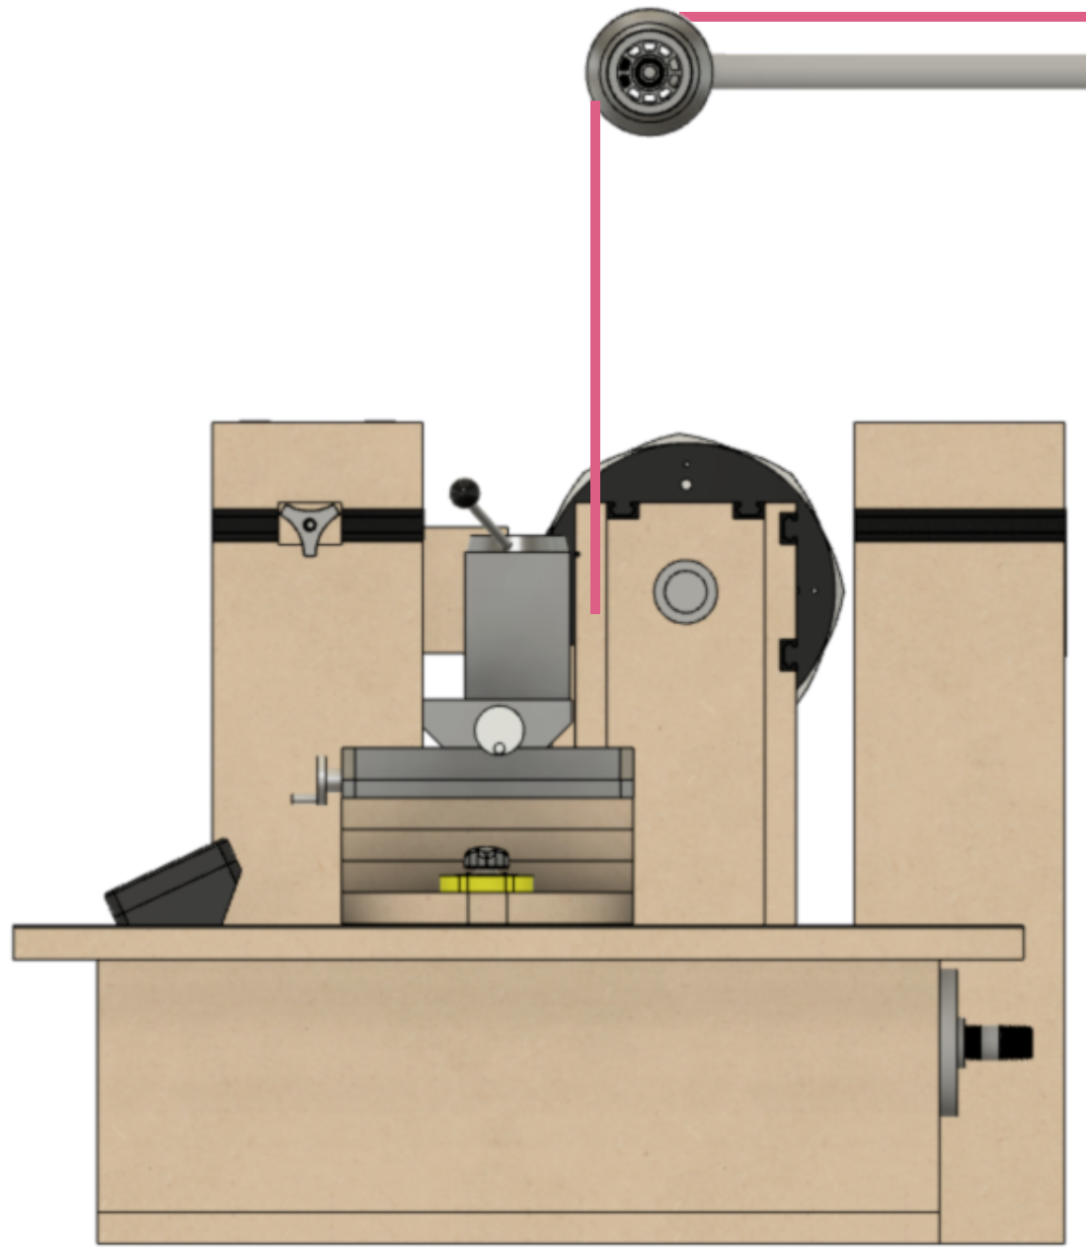

Figure - Overhead Drive Alignment

This only shows the view from the inboard side, but the alignment when viewed from the near side should be similarly aligned. In that case, the cable should be vertical when halfway thru the movement along the Z axis. So, it you are planning to move the cutting frame 2", then at 1", it should be vertical.

The last thing to check is that the tension on the overhead cable is right.

* Too much is not good, especially if you use the piston-style quick-change tool post as it can pull the cutting frame or drilling spindle up.
* Too little is also not good as it can allow the drive cable to “flop around” creating too much vibration in the cutting.

This is also the reason you should keep the vertical distance short. Reduce the length of the cable if needed.

### Step 9: Consider Using Limit Switches

If you are cutting a flute or making any other cut where a stepper motor is engaged to move the cutting frame (or drill spindle), consider using a limit switch. The limit switch connects to the Control System for Multiple Stepper Motors, and once the cutting frame engages the limit switch, the cutting frame motor will be automatically stopped. This can help prevent the stepper motor from creating problems when trying to move too far.

One ornamental turner holds the limit switches he uses in a Noga arm, enabling him to move it around wherever it is needed. In the MDF Rose Engine Lathe 2.0 Library, there is a black book titled, “3D Printed Parts”. That has some mounts which can be 3D printed to attach the recommended limit switches ( McMaster-Carr, part number 7779K13).

More information about the implementation of limit and home switches is on the limit switches config page in the “Users Guide to the Control System for Multiple Stepper Motors”.

### Step 10: Being Sure Everything is Locked Down Before Starting

OK, this may seem unnecessary to state, but we speak from experience. We've all had a time when we thought we were ready to go, only to find out something wasn't right somewhere down the line.

The most common problem I've encountered is to not have the cutting frame well secured in the quick-change tool post, and the cutting frame inched its way up as the cutting goes along. But I've also had the problem where the MagSwitches were not engaged. This too became problematic at some point.

So, take the time to check to be sure everything is secured well before kicking off the cutting.

### Step 11: Do a Test Cut

Even when you think everything is perfect and ready to go, doing a test cut is something I like to do. This comes in one of these forms:

1. When cutting down to the final form, check the pattern as you go to ensure it looks the way you envisioned. This is especially useful to ensure
   1. You are using the right shape for your cutter's cutting edge, and
   2. The radius of the cutting tool is right.
2. If this is the first time you are making the object, make one out of a different (much less expensive) wood. This prototype will let you
   1. ensure the final form is what you want,
   2. ensure the sequence of cuts is the right way to approach the final form (at times I have reversed the sequence of cutting),
   3. ensure the approaches to the cuts is best (i.e., that the way you are holding the cutting frame relative to the object is best), and
   4. document the work holding.

Here is a list of these steps you can print and laminate for ready reference.

|  |
| --- |
| **MDF Rose Engine Lathe 2.0**  **Setup Checklist** |
| 1. Center the headstock 2. Align the object in the chuck 3. Choose the cutting frame or drilling spindle to use 4. Align the cutter 5. Align the cross slide to the spindle 6. Ensure you are cutting in the correct direction 7. Set the speed for the cutting tool 8. Adjust the overhead to be vertical 9. Consider using limit switches 10. Lock everything down 11. Make a test cut (or more than 1) |

# Paper Chucks

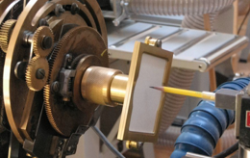A paper chuck is used to hold a piece of paper so that an image of the rosette's final product can be visualized. The shape of the rosette may not be readily evident about the product it will produce, plus the other variables like the rubber's shape can change what the rosette produces.

Figure - Typical Paper Chuck

A typical paper chuck is designed to hold a 4" x 6" index card, and Lindow Machine Works makes a very nice one. But other sizes of paper can be used also as shown in the home-made paper chuck to the right.

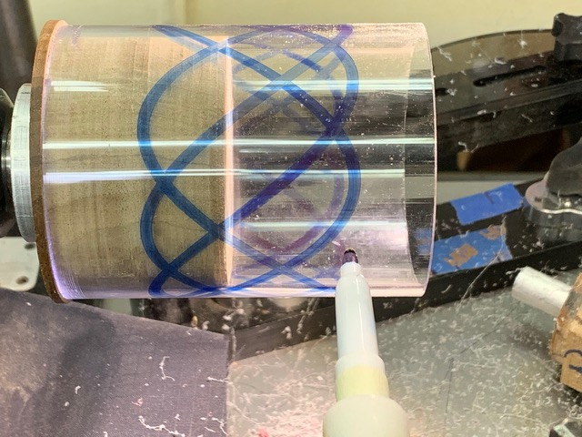

Whilst the traditional paper chuck can only be used to show the effects of rocking motion, not pumping motion. There have been some who have made one using a cylinder (say, using a cast acrylic or polycarbonate plastic tube) and used an erasable marker to trace the shape achieved. Such a device can indeed show pumping motion.

Figure - "Paper Chuck" showing side patterns

# Recommended Maintenance

## Quarterly Maintenance

### Vacuum Out Sawdust

Figure - Design. for Cleaning Out Sawdust

*(Parts removed for clarity)*

The bottom of the headstock is tapered towards the center and has an opening. This is to allow any sawdust which may enter the headstock to fall through into the base. The blue arrows in the picture to the right show the path this dust will follow.

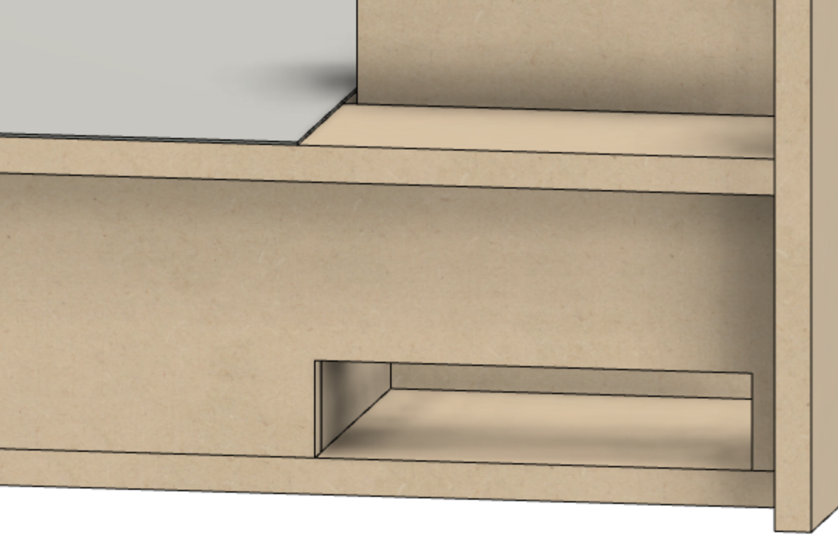  
There is also an opening in the far side of the base to allow for vacuuming out the sawdust which falls through (and around) the headstock. This is shown in the picture to the left.

Figure - Opening to Vacuum Out Dust

## Diagram Description automatically generatedAnnual Maintenance

### Lubricate the Spindle Shaft

The bronze bushings and thrust washers specified for the MDF rose engine lathe are oil impregnated and that lubrication will last a long time. Regardless, the spindle shaft should be lubricated annually to minimize wear. To do this,

1. On the outboard side, loosen the retaining set screw holding the main pulley flange in place and pull the flange away from the headstock.
2. On the inboard side, pull the spindle out a bit (as shown in the picture to the right) exposing the bronze flange bushing and bronze thrust bearing.

Figure 14 - Spindle Bushing

*(Spindle pulled out for clarity)*

1. Lubricate the mating surfaces on the bronze pieces, along with the part of the shaft that is enclosed by the bushing. Do this on both the inboard and outboard sides of the headstock.

Be sure to not over-lubricate the bushings as the lubricant will retain dust.

1. Re-assemble the pieces and tighten the flange set screw.

Recommended lubricants:

* Lightweight oil -- something like SAE 68 / 20-weight
* Silicon oil

# Standards

## Mechanical Standards

### Spindle

1. Work holding end will have a Morse Taper #2.
2. Shaft will accommodate a 3/8”-16 draw bar.
3. Shaft will be able to be used on the original MDF rose engine lathe.

### A close up of a device Description automatically generatedLathe Bed

1. Lathe bed shall be 24” square.

### Headstock

1. Headstock shall be positioned such that:
   1. 1/3 of the bed is behind the center line of the spindle
   2. 2/3 of the bed is forward of the center line of the spindle
2. Distance between the center line of the spindle and the headstock’s pivot points shall be 12”.

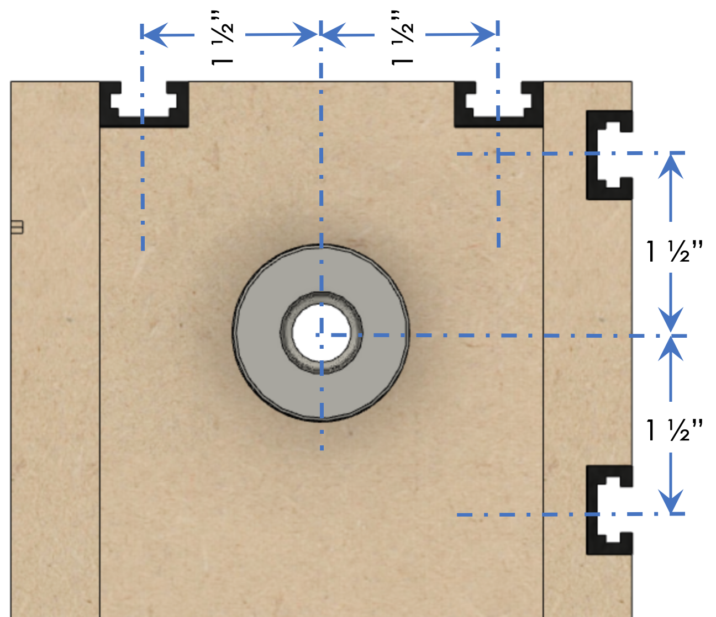

1. T-Tracks on the headstock shall be 1.5” from the centerline on the spindle.
   1. Two on top, and
   2. Two on the rear.

## Electrical Standards

### Conventions in this Document

In this document,

* Standards are documented using green tables
* Recommendations are documented using blue tables

### Nextion Display

1. Device

|  |  |
| --- | --- |
| Item | Standard |
| Model | Nextion Enhanced HMI Display |
| Size | 4.3” |

1. Cabling

|  |  |
| --- | --- |
| Item | Standard |
| Conductor Type | Ethernet Cat-5 (or higher) |
| Cable Size | 8 conductors / cable |

1. Connector

|  |  |
| --- | --- |
| Item | Standard |
| Connector | GX-12, 4 pins |
| Cable End | Female plug |
| Control Box | Male Socket |

1. Connector Configuration

|  |  |
| --- | --- |
| Item | Standard |
| Cabling Color Standard | EIA/TIA T568A |
| Power Pins | Power over Ethernet (PoE) standard 802.3af, 10/100 Mode A (mixed DC & data) |

|  |  |  |
| --- | --- | --- |
| Pin | Cable Wire Color | Use |
| 1 | White/Green | Rx on the Nextion  Tx on the Teensy |
| 2 | Green | DC+ (5V) |
| 3 | White/Orange | Tx on the Nextion  Rx on the Teensy |
| 4 | Blue | (unused) |
| 5 | White/Blue | (unused) |
| 6 | Orange | DC- / GND |
| 7 | White/Brown | (unused) |
| 8 | Brown | (unused) |

### 

### Stepper Motors

#### Spindle Stepper Motor

|  |  |  |
| --- | --- | --- |
| Item | Standard | Recommended |
| Size | NEMA 23 |  |
| Motor Type | Bipolar Stepper |  |
| Step Angle | 1.8 deg |  |
| Microstep Resolution | 6400 |  |
| Min. Holding Torque | 1.9Nm (269oz.in) |  |
| Max. Rated Current/phase | 4A | 2.8A |

#### Other Stepper Motors

|  |  |  |
| --- | --- | --- |
| Item | Required | Recommended |
| Size | - n/a - | NEMA 17 |
| Motor Type | Bipolar Stepper |  |
| Step Angle | 1.8 deg |  |
| Microstep Resolution | - n/a - | 6400 |
| Min. Holding Torque | - n/a - | (as needed) |
| Max. Rated Current/phase | 4A |  |

### General

1. Cabling

|  |  |  |
| --- | --- | --- |
| Item | Standard | |
| Conductor Type | | Stranded copper |
| Conductor Size | | 20 AWG |
| Cable Size | | 4 conductors / cable |

1. Connector

|  |  |  |
| --- | --- | --- |
| Item | Standard | |
| Connector | | GX-16, 4 pins |
| Cable Ends | | Female plug |
| Control Box | | Male Socket |

1. Connector Connection Standard & Cable Color Recommendation

|  |  |  |  |
| --- | --- | --- | --- |
| Pin | Use | Cable Wire Color | StepperOnline Stepper Motor Lead Color |
| 1 | A+ / A1 | Black | Black |
| 2 | A- / A2 | Yellow | Green |
| 3 | B+ / B1 | Red | Red |
| 4 | B- / B2 | White | Blue |

### Stepper Motor Drivers

1. Device

|  |  |  |
| --- | --- | --- |
| Item | Standard | |
| Model | | DM542T |

1. Power Cabling

|  |  |  |
| --- | --- | --- |
| Item | Standard | |
| Conductor Type | | Stranded copper |
| Conductor Size | | 20 or 22 AWG |
| Cable Size | | 2 conductors / cable |

1. Power Cabling Configuration

|  |  |
| --- | --- |
| Item | Cable Wire Color |
| Positive (+) | Red |
| Negative (-) | White (or Black) |

1. Signal Cabling

|  |  |  |
| --- | --- | --- |
| Item | Standard | |
| Conductor Type | | Stranded copper |
| Conductor Size | | 20 AWG |
| Cable Size | | 4 conductors / cable |

1. **Connectors**: Cable conductors are directly connected to the DM542T using the provided screw terminals.
2. Power Cabling Configuration

|  |  |  |
| --- | --- | --- |
| Item | Cable Wire Color | |
| Pulse + | | Black |
| Pulse - | | White (GND) * |
| Direction + | | Red |
| Direction - | | White (GND) * |
| Enable + | | Yellow |
| Enable - | | White (GND) * |

* GND wires tied / bonded together.

### DC Power Supply1

1. Device

|  |  |  |
| --- | --- | --- |
| Item | Standard | |
| Model (USA) | | Mean Well EDR-120-24 |
| Input | | 120 VAC |
| Output | | 24 VDC |

1. DC Power Cabling

|  |  |  |
| --- | --- | --- |
| Item | Standard | |
| Conductor Type | | Stranded or solid copper |
| Conductor Size | | 20 or 22 AWG |
| Cable Size | | 2 conductors / cable |

1. DC Power Cabling Configuration

|  |  |  |
| --- | --- | --- |
| Item | Cable Wire Color | |
| Positive (+) | | Red |
| Negative (-) | | White (or Black) |

1. AC Power Cabling

|  |  |  |
| --- | --- | --- |
| Item | Standard | |
| Conductor Type | | Stranded copper |
| Conductor Size | | 16 AWG (min) |
| Cable Size | | 3 conductors / cable |

1. AC Power Cabling Configuration

|  |  |  |
| --- | --- | --- |
| Item | Cable Wire Color | |
| Hot (or live or active) | | Black |
| Neutral | | White |
| Ground | | Green |

1. **AC Power Switching Configuration**: Hot (or live or active) is switched on the infeed to the DC power supply.

### Limit Switches

#### General

1. Cabling

|  |  |  |
| --- | --- | --- |
| Item | Standard | |
| Conductor Type | | Stranded copper, shielded |
| Conductor Size | | 26 AWG (min) |
| Cable Size | | 2 conductors / cable  (1 conductor is the shield) |

1. Connector

|  |  |  |
| --- | --- | --- |
| Item | Standard | |
| Connector | | 3.5mm (1/8”) mono |
| Cable Ends | | Female plug |
| Control Box | | Male Socket |
| Limit Switch | | (directly cabled) |

1. Connector Configuration

|  |  |  |
| --- | --- | --- |
| Pin | Standard | Cable Wire Color |
| Tip | DC+ | Red |
| Sleeve | GND | White |

#### Limit Switch

|  |  |
| --- | --- |
| Item | Standard |
| Switch Type | Normally open, momentary close, or  Normally close, momentary open |

# Design Goals

### Guiding Principles

#### Target User

* The target user for the MDF rose engine lathe 2.0 is
  + An experienced woodturner, with
  + The basic woodworking skills that would have been garnered in shop class.
* The design will ensure it can be built by the woodworker
  + Using a kit of parts we will provide, or by building their own according to instructions to be published,
  + Possessing basic woodworking skills, and
  + Using tools which can reasonably be expected to be available (or easily accessible).

#### Overall Design

* The intent is to stay consistent with the original overall design outlined by Jon Magill, especially the designs built into the rosettes.
* The design will continue to use MDF as the primary building material for the headstock and base.
* The design will include commonly implemented updates to the original design, including,
  + Stepper motor for the spindle drive,
  + Metal sheet on the lathe's bed,
  + Magnetic hold-downs (MagSwitches) for locking the cross slide into position on the lathe bed,
  + Front and rear rubbers, and
  + Amplitude adjusting (front rubbers only).
* The design will not include previously offered features which would make the new overall design cumbersome or expensive. In particular, hand cranking capabilities will not be included.
* The design will provision for known future options / expansions, including
  + Multiple stepper motors with controls for the multiple stepper motors, and
  + Pumping on the spindle.

#### Kit Offered for Sale

* The design should enable a complete rose engine lathe to be built from a kit for less than $4,000. And the design should be designed to be much lower if the user opts to make their own parts.
* The kits offered for sale will provide options which, in total, will supply the hobbyist with all the parts needed (including the MDF).
  + Using standard, off-the-shelf parts, with a conscious decision being made when customized parts are to be used,
  + Sourcing parts from vendors likely to provide the parts for a reasonable time into the future (i.e., minimizing rework of the designs), and
  + Sourcing more expensive parts from vendors who will accommodate drop-shipments. This reduces the investment in inventory for the provider of the kits.

# Frequently Asked Questions

The questions below are commonly asked, and responses are given to help the reader.

### General

Does this design accommodate both rocking and pumping?

This kit provides for rocking, and there have been a number of people who have adding pumping capabilities. That capability is not provided by this kit at this time.

As we evolve and add to the system features over time, we will evaluate and consider adding it to the system. It is expected to be an add-on to the base system and will not require changes to the design we have delivered.

None-the-less, if you are new to ornamental turning, there are so many capabilities provided by this machine that it will probably be a long time before you find the lack of pumping to be a limitation to your artistic endeavors (at least I haven’t yet).

Does this design accommodate a barrel approach with more than two rosettes?

The use of more than two rosettes at one time is something not accommodated by the design of this lathe. We have spoken with a large number of MDF rose engine lathe users, and none have expressed that using only two rosettes at one time has limited their capabilities.

Instead, the ability to easily switch rosettes is a design feature for this machine. Other unique features for this machine include:

1. The ability to easily change the phasing of the rosettes (vs. the object) without having to perform any calculations.
2. The ability to change the phasing of one rosette against the other rosette.

So, if you are new to ornamental turning, this machine will enable you to pursue your artistic endeavors easily and without having to spend great amounts of time learning how.

Where can I learn more about ornamental turning?

There are a number of great good options:

* Join the Ornamental Turners International. There is a forum on the web site which allows for questions to be posed and are typically answered relatively soon.
* Attend the Ornamental Turners International Symposium. There, you will meet many other users of the MDF rose engine lathe.
* Check out the Ornamental Turning Book of Knowledge (https://OTBoK.info)(https://OTBoK.info). There is also a list of additional resources on that site.

What Do I Need to Get Started?

A document has been added to the MDF Rose Engine Lathe 2.0 Library outlining this. It is the green book titled, “*How Do I Buy an MDF Rose Engine Lathe?*”

### Spindle

May I get a spindle with spindle threads of 1 ¼”-8 (or M33)?

The kit as designed with a Morse Taper in the spindle, and an adapter which we are offering is 1”-8. Other adapters, including 1 ¼”-8 are available, and the user can certainly look into those.

May I get a spindle with a Morse taper?

This is part of the design for the MDF Rose Engine Lathe 2.0. (That spindle can also be used in the original MDF Rose Engine Lathe.)

### Spindle Drive

Do you sell a kit with the hand crank as an option?

Haven spoken with many MDF rose engine lathe users, almost all have motorized the spindle drive. Many have used geared motors with the speed controlled by changing the frequency of the power feed. Whilst that works, it is problematic at slower speeds as torque is lost. The hand crank was used when cutting at very slow speeds (e.g., when making the final passes on a cut).

Stepper motors provide a much better option as they maintain torque when running across the speed range used on the rose engine lathe. And, using stepper motors ensures a constant rotational speed when running at slower speeds, speeds measured in multiple minutes per revolution.

The result of such constant speed is that the work produced will be much higher quality.

Do you sell a kit which accommodates multiple stepper motors?

There are two options at this time:

* A controls kit which implements a spindle stepper motor only, or
* A controls kit which will control up to two stepper motors at the same time: The spindle stepper motor and one other.

These are outlined in the user manuals (which are available on-line in the MDF Rose Engine 2.0 Library and are kept up to date).

May I get a different sized (or different amperage) stepper motor in my kit?

That is not an option we support at this time. The supplied kit is designed to work along known parameters. The NEMA 23 stepper motor we have specified and tested has shown to have sufficient power. You are certainly welcome (and encouraged) to experiment.

May I use a different sized (or different amperage) stepper motors?

The standards around which the system is developed are outlined in this document.

May I get a different stepper motor controller or driver in my kit?

That is not an option we support at this time. The supplied kit is designed to work along known parameters. You are certainly welcome (and encouraged) to experiment.

May I use a different stepper motor controller or driver?

The kit has been designed to easily utilize a very cost-effective approach to having a stepper motor drive the spindle. If you want to use a different controller or driver, you may, and are welcome to experiment.

## A picture containing diagram Description automatically generatedWhat Changed with the MDF Rose Engine Lathe 2.0?

The changes incorporated into the MDF Rose Engine Lathe 2.0 include:

1. The overall design is documented to allow for other components to be made and added to this base design.
2. The machine is designed for using a stepper motor drive on the spindle. There is no longer an accommodation for manually turning the spindle.
3. This machine has 2" more clearance over the bed. The center line of the spindle to the top of the bed is now around 8".

Figure - Rubber on Near Column

* 1. 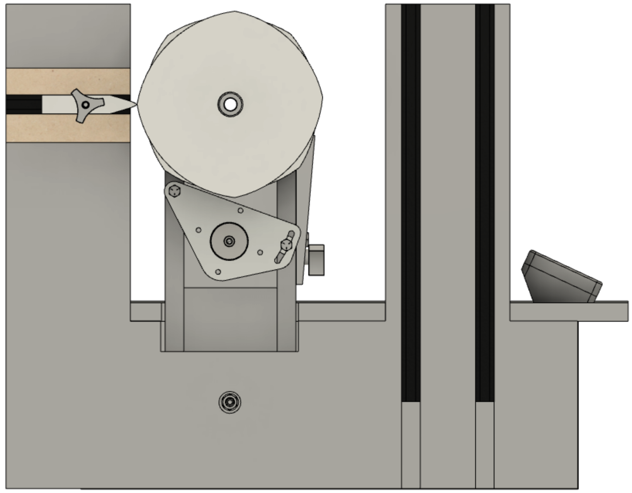The distance from the pivot point to the spindle on the headstock is 1" longer, and
  2. The pivot points are set to be 1" higher in the base.

1. This machine comes with a spindle which has a Morse taper rather than a 1" - 8 TPI threaded end.
2. The rubber support tower was completely redesigned as shown in the pictures to the right:
   1. There are both near and far rubber support capabilities.

Figure - Rubber on Far Column

* 1. 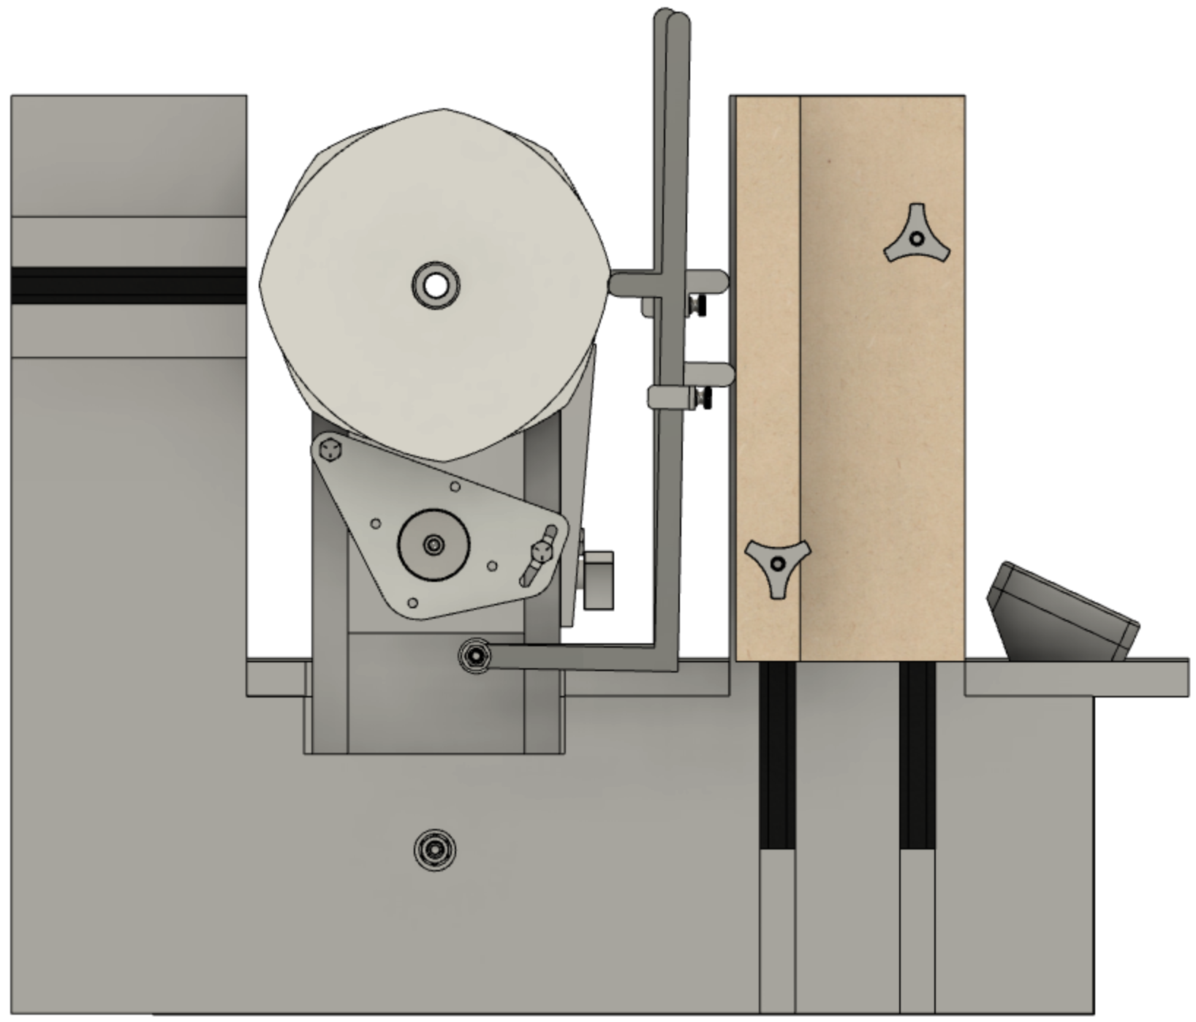Support is included for the use of at least two different types of amplitude adjusters.
     1. The front rubber support tower was moved further away from the spindle.
     2. The rubber holder for the near rubber can be flipped and moved vertically. This easily accommodates using an amplitude adjuster.
  2. The amplitude adjuster will also accommodate two rosettes, each with its own, separate amplitude adjuster (shown installed in the picture to the right).

Figure - Dual, Independent Amplitude Adjusters

1. The bed is larger (24" x 24") and is designed to have a steel sheet on the top where magnetic switches can hold the cross slide (or other component) in place. 16 gauge is the minimum thickness that is usable, however 3/16” is recommended.
2. 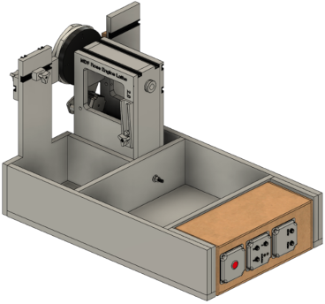The controls are being sold as a pre-wired unit that is "plug in, hook up, and go". Soldering is not required, nor is having to figure out which wires get connected to what and how.

Figure - Controls Box Under the Lathe's Bed

The instructions are also published on the MDF Rose Engine Lathe 2.o Library in case you want to do it yourself or change what was done.

1. These controls are also designed to be placed under the bed of the MDF rose engine lathe 2.0. If added to the original MDF rose engine lathe, it can be set to the side.   
     
   The upper picture to the right shows the controls under the bed of the MDF rose engine lathe 2.0 (the bed cover has been removed). This allows the other open areas to be used as the owner wishes.
2. The controls for the stepper motors are designed for:
   1. Driving the spindle using a stepper motor.

Figure - Lathe Axes

* 1. Simultaneously controlling one additional stepper motor for activities such as driving movement on the cross slide.
  2. Connecting stepper motors with up to 4 amps of current draw.
  3. Incorporating the use of limit switches.
  4. Controlling stepper motors in 4 axes of motion (Spindle, X, Z, and B).
  5. Delivering user functionality in the controls such as
     1. Indexing,
     2. Threading,
     3. Reciprocation,
     4. Cutting flutes and helices,
     5. Cutting a Greek key/ meander pattern, and
     6. Emulating a geometric chuck for rose patterns.
  6. Using a touchscreen for managing these movements.
  7. Implementing and publishing standards for all the connectors, allowing for ease in development and use of future add-ons. This includes:
     1. Stepper motors - the system accommodates the spindle drive plus connecting to 3 more,
     2. Limit switches - the system accommodates quite a few, and
     3. Nextion touch-screen display for making it easy to control the operation.

1. The stepper drive parts, and the control box are all available to add to an existing MDF rose engine.
2. 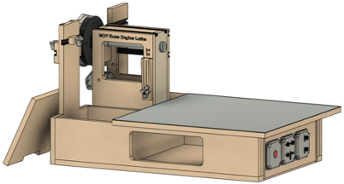The picture to the right shows part of the lathe bed removed (as it was designed to be more of a lid than part of the bed proper), and part of the front side cut away to allow for storage there also. The cut-out part is certainly something the user can do.

Figure - Storage Options

1. The headstock has T-Track on the top and back, and the placement of these is set as a standard so others can make add-ons (e.g., a tail stock).
2. Dust removal is easier. The headstock allows dust to fall thru to the base, and there is an opening on the back to allow it to be vacuumed out. (You no longer have to shoot compressed air into the headstock or the space around the headstock whilst keeping your eyes closed.)
3. If you already have an MDF rose engine lathe, you can upgrade to the 2.0 version by making the new MDF parts according to the instructions or buying the pre-cut kit. Some of your T-tracks will be re-usable but it may be best to buy new ones.

Figure - Opening to Vacuum Out Dust

1. 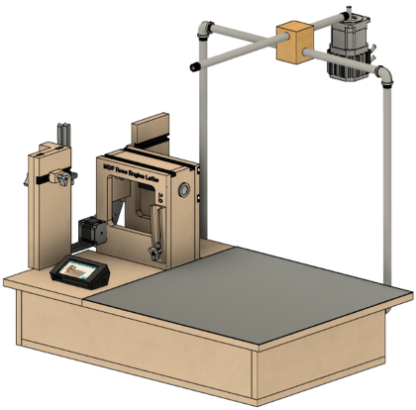An overhead drive is designed like the original Holtzapffel approach (giving it a little bit of a legacy look). You can see it in the picture of it on the right.

Figure - Overhead Drive

1. The complete system can be purchased as a kit for easy assembly. This system components, all of which can be purchased separately, include:
   1. Base kit (like Jon Magill used to provide, but with a spindle with a Morse taper),
   2. Pre-cut MDF parts,
   3. Overhead drive,
   4. Cross slide,
   5. Stepper motor controls and spindle drive stepper motor, and
   6. Universal cutting frame.
2. Detailed instruction guides are available for the woodworker who wishes to build their own.
3. All documentation is being provided electronically and will be kept up-to-date and available online for free.

Also, the user manual for the stepper motor controls is on-line. The manual works like the application does and provides information on the screen which is relevant to the operation being started.

## What Did Not Change with the MDF Rose Engine Lathe 2.0?

The things which did not change with the MDF Rose Engine Lathe 2.0 include:

* The overall intent for the machine was maintained. It should be easy to use and not require a lot of math.

Make it easy to make art

* The base system is still made from 3/4" MDF.
* The same rosettes are still used.
* The spindle still has a 1" diameter, and the headstock's width & depth is the same (the height is greater). Thusly, if you choose to build the new headstock and base, your existing spindle can be reused.
* Stepper motors are only used where synchronized movement is needed. There is no attempt to make this a CNC lathe.

To the extent that material may appear to be infringed, we assert that such alleged infringement is permissible under fair use principles in U.S. copyright laws. If you believe material has been used in an unauthorized manner, please contact me at [ColvinTools@Gmail.com](mailto:ColvinTools@Gmail.com).

Portions of this document are copyrighted by Jon Magill and are used with his permission.